**WEEK - 4**

1.Arjun recently watched HarryPotter series and he wants to know more details about the characters. So, design a web application which helps him to know about the characters of the series. Potter wants the website to be more interactive so strictly make use of angular material.

Details to be displayed for each character:

Name,Role,House,School,BloodStatus and Species

NOTE: Strictly get data from the POTTER API

API url: <https://www.potterapi.com/>

Outcomes:

Learn and apply Services and Http Module

2.Murthy is a lecturer so he wants to store the details of his students.Being a lecturer he is so busy in his work. So,help him to create a web application which helps him to add details of the students.

Details to be stored:-

Name,Id,Telephone No,Email,Gender,Date Of Birth,..etc

Demo View:

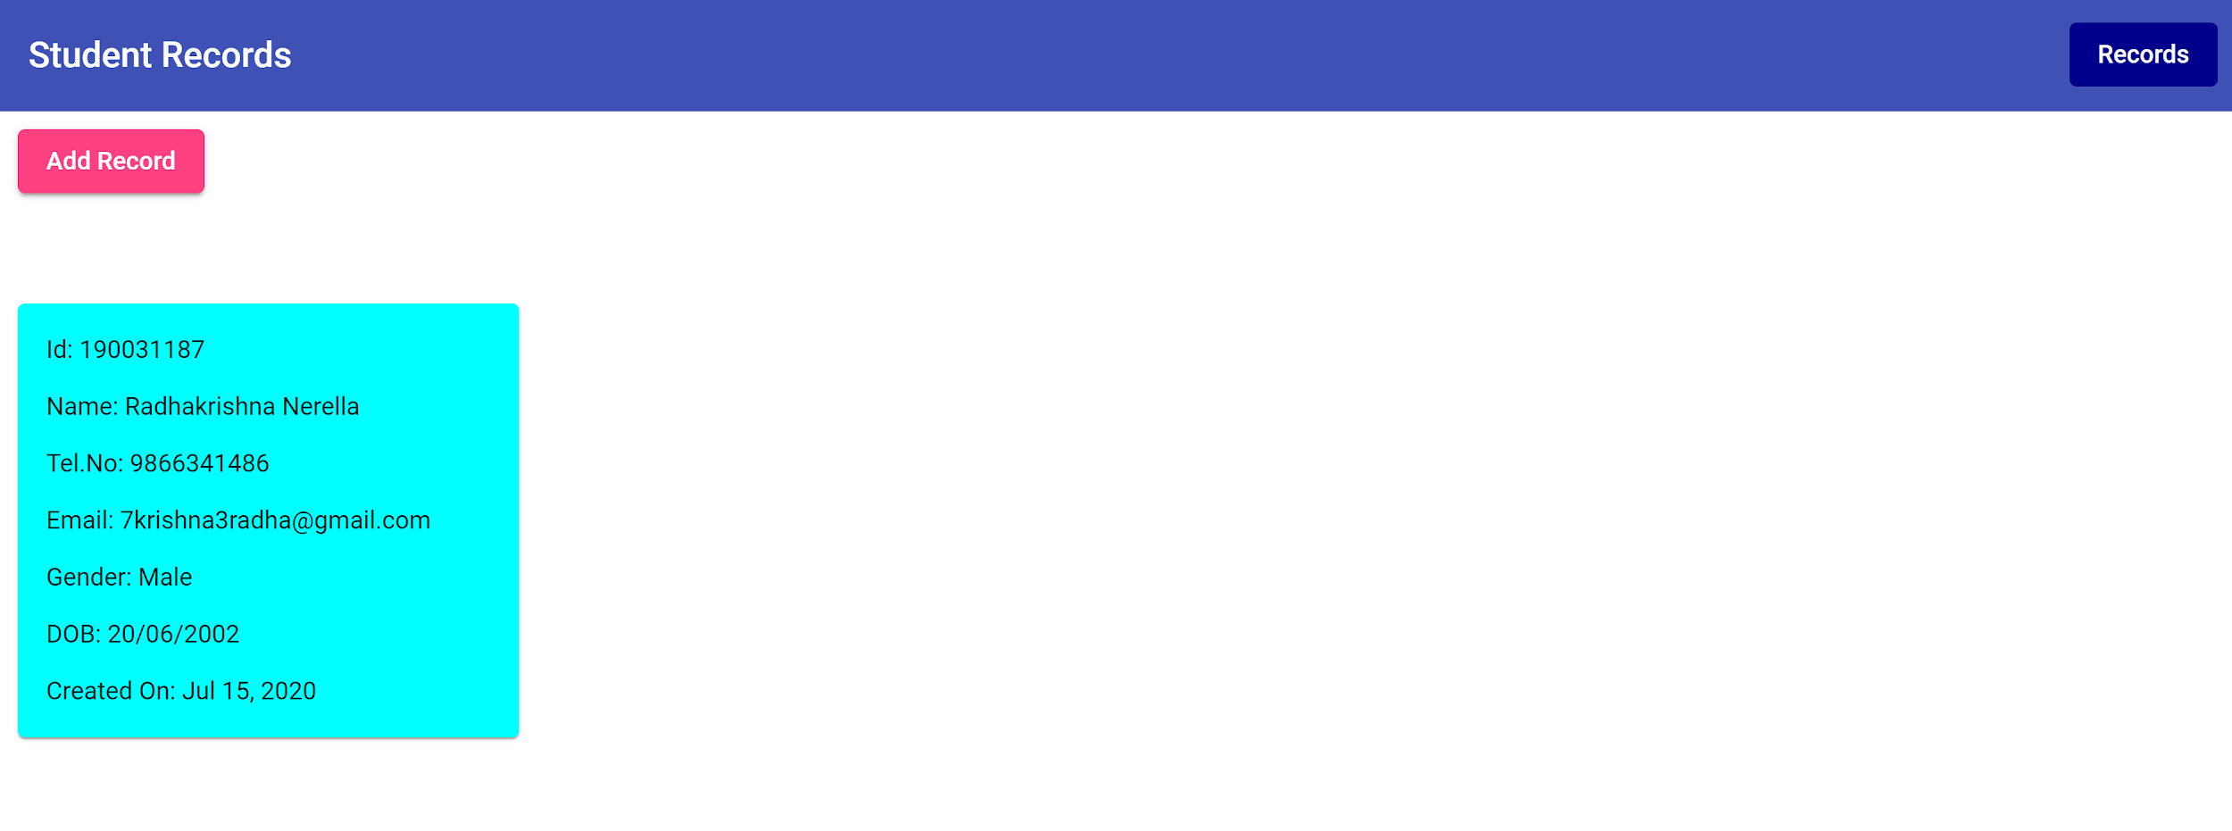

Note:-

Store the Details in a Array,

Form Validations are mandatory,

Use DatePicker for Date Of Birth in Angular Material(Optional),

The UI need not to be similar(It is your wish),

Handle Error when try to route to a location which does not exist

Outcomes:

Learn and Apply Angular Forms And Routing